|  |  |  |
| --- | --- | --- |
| **Heswall Jnrs** | **Vs** | **CUGC U14s** |
|  | **Singles-Matchplay** |  |
| **Sun 28th Apr 24** |  | **First Tee 1146** |

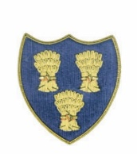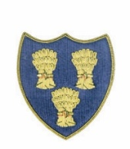

**Cheshire Union of Golf Clubs**

|  |  |  |  |  |  |  |  |
| --- | --- | --- | --- | --- | --- | --- | --- |
| **Heswall Players** | | | | **CUGC U14s Players** | | | |
| Max Brett 4.4 | 4 |  | 2/1 | Max Gilsenan-Chorlton Cum Hardy 5.5 | 6 | +2 |  |
| Ben Hall 7.2 | 7 | +1 | half | Harry Payne-Caldy 5.5 | 6 |  | half |
| Alfie Walker 9.1 | 9 | +1 | half | Noah Alexander-Eaton 7.8 | 8 |  | half |
| Reece Brook 9.7 | 10 | level | 3/2 | Esme Graham 8 | 8 | level |  |
| Callum Miller 12.6 | 13 | +7 | 2/1 | Alfie Ogden-Wallasey 6.4 | 6 |  |  |
| Sonny Eyes 15.4 | 15 | +7 |  | Shane Clayton-Delamere Forest 8.4 | 8 |  | 1up |
| Peter Morris 15.4 | 15 | +7 | 6/5 | Jeremy Ju-Hazel Grove 8.4 | 8 |  |  |
| Edward Hellier 22.5 | 23 | +7 |  | Pierce Freeman-Delamere Forest 15.8 | 16 |  | 2up |
|  |  |  |  | **James Harrison-Astbury 8.5 In-house | 9 | +1 |  |
|  |  |  |  | **Thomas McCann-Hazel Grove 8.3 in-house | 8 |  | 4/3 |
|  |  |  |  |  |  |  |  |
|  |  |  |  |  |  |  |  |
|  |  |  |  |  |  |  |  |
|  |  |  | 5 |  |  |  | 4 |