|  |  |  |
| --- | --- | --- |
| **Royal Liverpool Jnrs** | **Vs** | **CUGC U14s** |
|  | **Royal Liverpool**  **Golf Club** |  |
| **Sun 5th May 24** |  | **First Tee 1320** |

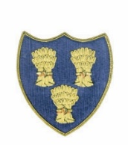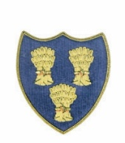

**Cheshire Union of Golf Clubs**

|  |  |  |  |  |  |  |  |
| --- | --- | --- | --- | --- | --- | --- | --- |
| **Royal Liverpool Players** | | | | **CUGC U14s Players** | | | |
| Max Brett 4.4 | 4.4 | 8 |  | Jasper Hughes-Wilmslow | 4.3 | 8 | 5/4 |
| Leonardo Hirons 4.6 | 4.6 | 9 | 7/6 | James Clark-Sandiway | 4.5 | 8 |  |
| Freddie Wilcock 5.4 | 5.4 | 9 | 3/2 | Harry Payne-Caldy | 5.6 | 10 |  |
| Eamon Palmer 5.7 | 5.7 | 10 |  | Max Gilsenan-Chorlton | 5.5 | 10 | 7/6 |
| Jack Astbury 9 | 9 | 14 |  | Josh Hockenhull-Mottram Hall | 7 | 12 | 3/2 |
| Callum Miller 12.6 | 12.6 | 19 | 1Up | Noah Alexander-Eaton | 7.2 | 12 |  |
| Sonny Eyes 15.4 | 15.4 | 22 |  | Austin O’Connor-Prestbury | 8 | 13 | 3/2 |
| Tomas Balakrishnan 16.1 | 16.1 | 23 | 5/4 | Pierce Freeman-Delamere Forest | 15 | 23 |  |
|  |  |  |  |  |  |  |  |
|  |  |  |  |  |  |  |  |
|  |  |  |  |  |  |  |  |
|  |  |  |  |  |  |  |  |
|  |  |  |  |  |  |  |  |
|  |  |  | 4 |  |  |  | 4 |