|  |  |  |
| --- | --- | --- |
| **Sandiway Juniors** | **Vs** | **CUGC U14s** |
|  |  |  |
| **Sun 9th June 24** |  | **First Tee 1510** |

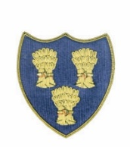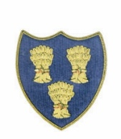

**Cheshire Union of Golf Clubs**

|  |  |  |  |  |  |  |  |
| --- | --- | --- | --- | --- | --- | --- | --- |
| **Sandiway Juniors** | | | | **CUGC U14s Juniors** | | | |
| *James Clarke 3.3 | 6 |  | A/S | *Josh Hockenhull 3.4 | 6 |  | A/S |
| Fin Waterhouse 4.0 | 7 |  | 2Up | *Will Furness-Ringway 4.2 | 7 |  |  |
| Mason Moore 4.8 | 8 |  |  | Jasper Hughes 5.0 | 8 |  | 3/2 |
| Jack Roache 14.7 | 20 |  |  | *Aidan Lam-Prestbury 6.7 | 10 |  | 5/3 |
| George Macfie 15.9 | 22 |  | 3/2 | Esme Graham-Wallasey 7.1 | 11 |  |  |
| Jamie Yarwood 17.9 | 24 |  | 3/2 | Harvey Taylor-Prestbury 7.4 | 11 |  |  |
| Jay-Jay McCarthy 17.7 | 24 |  |  | George Bull-Disley 9.3 | 14 |  | 4/2 |
| Corey Lewis 20.9 | 28 |  |  | *Ricky Mohun-Delamere Forest 9.6 | 14 |  | 3/1 |
|  |  |  |  | **Toby Cooper-Ringway 9.6 In-house | 14 |  |  |
|  |  |  |  | **Thomas McCann-Hazel Grove 8.2 In-house | 12 |  |  |
|  |  |  |  | **In-house game - Toby won 2/1 |  |  |  |
|  |  |  |  | *Congratulations-Mars Bar Challenge - Award |  |  |  |
|  |  |  |  |  |  |  |  |
|  |  |  | 3.5 |  |  |  | 4.5 |