|  |  |  |
| --- | --- | --- |
| **CUGC U14s** | **Vs** | **LANC’S U14s** |
|  |  |  |
| **Sat 27th July 24** |  | **First Tee 1400** |

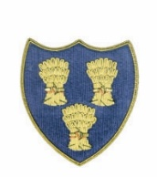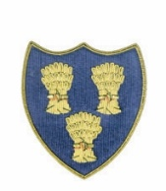

**Cheshire Union of Golf Clubs**

|  |  |  |  |  |  |  |  |
| --- | --- | --- | --- | --- | --- | --- | --- |
| **CUGC U14s** | | | | **LANC’S U14s** | | | |
| James Clark-Sandiway |  |  | 1/2 | Oliver Coleman-Ashton-Under-Lyne 2.1 |  |  | 1/2 |
| Josh Hockenhull-Prestbury 3.0 |  |  |  | Gabriel Ridgeway-Lancaster 2.9 |  |  | 1 Up |
| Will Furness-Ringway 3.7 |  |  | 1/2 | Leo Taylor-Ormskirk 3.9 |  |  | 1/2 |
| Jasper Hughes-Wilmslow 4.8 |  |  |  | George Crompton-West Lancs 6.0 |  |  | 4/3 |
| Mason Moore 4.8 |  |  | 3/1 | William Tate-West Lanc’s 6.2 |  |  |  |
| Max Gilsenan-Chorlton 5.4 |  |  | 1 Up | Joe Green-Dunscar 6.9 |  |  |  |
| **\***Noah Alexander-Eaton 5.7 |  |  | 3/2 | James Powell-Dean Wood 9.0 |  |  |  |
| **\***George Bull-Disley 6.8 |  |  | 2/1 | Will Hardwicke-Hart Common 11.1 |  |  |  |
| Jeremy Ju-Hazel Grove 8.9 |  |  | 1/2 | Jessica Bagley-Preston 9.3 |  |  | 1/2 |
| **\***Ricky Mohun-Delamere Forest 7.8 |  |  | 1 Up | Xavier Good-Hart Common 12.5 |  |  |  |
|  |  |  |  |  |  |  |  |
| PGA Pro Matt Turnock |  |  |  | PGA Pro Craig Lee |  |  |  |
|  |  |  |  |  |  |  |  |
|  |  |  | 6.5 |  |  |  | 3.5 |