|  |  |  |
| --- | --- | --- |
| **Wallasey Juniors** | **Vs** | **CUGC U14s** |
|  | **Wallasey Golf Club** |  |
| **Sunday 8th Sept** |  | **First Tee 1300** |

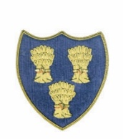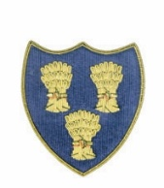

**Cheshire Union of Golf Clubs**

|  |  |  |  |  |  |  |  |
| --- | --- | --- | --- | --- | --- | --- | --- |
|  | | | | **CUGC U14s Squad** | | | |
| Alfie Ogden 4.9 | 7 | 5 |  | James Clark-Sandiway 0.7 | 2 |  | 6/4 |
| Thomas Littlewood 8.6 | 11 | 7 |  | Jasper Hughes-Wilmslow 2.5 | 4 |  | 6/5 |
| Callum Miller 9.3 | 12 | 6 | H | Harry Payne-Caldy 3.9 | 6 |  | H |
| Jack Roche 10.2 | 13 | 8 | 3/2 | Austin Eastwood –Caldy 3.5 | 5 |  |  |
| Seamus McMahon 11.3 | 14 | 7 |  | Will Furness-Ringway 5.0 | 7 |  | 7/6 |
| Tomas Balakrishnan 11.8 | 15 | 8 |  | Ricky Mohun-Delamere Forest 4.9 | 7 |  | 4/3 |
| Harry Grey 14.7 | 18 | 11 |  | Shane Clayton-Delamere Forest 4.7 | 7 |  | 5/4 |
| Sophie Sparkes 19.4 | 27 | 19 | 1Up | Thomas McCann-Hazel Grove 5.9 | 8 |  |  |
| Yasmine Chambers 21.9 | 30 | 20 | 5/4 | Toby Cooper-Ringway 7.5 | 10 |  |  |
| Isabella Donnelly 28.6 | 38 | 26 | 5/4 | James Harrison-Astbury 9.4 | 12 |  |  |
|  |  |  |  |  |  |  |  |
|  |  |  |  |  |  |  |  |
|  |  |  |  |  |  |  |  |
|  |  |  | 4.5 |  |  |  | 5.5 |