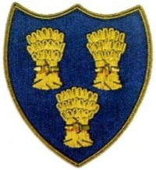
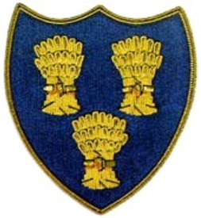
Cheshire Golf U14s
COURSE:-CONWAY GOLF CLUB
DATE:- SUNDAY 12TH OCTOBER 25
ARRIVE 0830 LATEST – FIRST TEE 0933

Caernarvonshire U14s |  |  |  | Cheshire U14s
Rosie Parsley-Conwy 3.9 | 5 |  |  | Morgan Bollan-Crewe +1.6 |  |  | 1Up
Ifan Owens-Caernarfon 7.2 | 7 |  |  | James Clark-Sandiway 0.1 |  |  | 2Up
Culhwch Deveraux-Conwy 10.1 | 9 |  | 6/5 | Austin Eastwood-Caldy 0.4
Luca Williams-Conwy 11.1 | 9 |  | A/S | Max Gilsenan-Chorlton Cum Hardy 0.8 |  |  | A/S
Fflur Cullen-Pwllheli 12.9 | 9 |  |  | Ricky Mohun-Delamere Forest 1.4 |  |  | 6/5
Amy Brown-Conwy 13.1 | 9 |  |  | George Bull-Disley 1.4 |  |  | 4/2
Elgan Vereau-Nefyn 13.6 | 9 |  |  | Will Furness-Ringway 1.9 |  |  | 5/4
Finn Brown-Conwy 16.7 | 9 |  |  | Alfie Ogden-Wallasey 2.9 |  |  | 1Up
Owain Williams (12) Caernarfon 18.4 |  |  |  | Shane Clayton-Delamere Forest 3.0 |  |  | 6/4
Iago Millington (11) Caernarfon 19.2 |  |  |  | Alfie Dunbar-Heswall 5.7 |  |  | 3/2
 |  |  | 1.5 |  |  |  | 8.5

