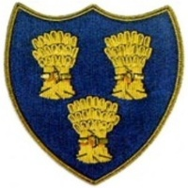
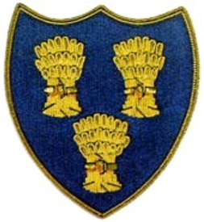
Cheshire Golf U14s
VENUE:- NELSON GOLF CLUB
DATE:- SUNDAY 10TH AUGUST 25
TIME:- ARRIVE 0915 LATEST-FIRST TEE 1030

LANCASHIRE U14s |  |  |  | CHESHIRE U14s
Lewis Forsyth-Hillside |  |  | 2up | Max Gilsenan-Chorlton Cum Hardy
James Powell-Dean Wood |  |  | 1up | Will Furness-Ringway
George Pendleton Nash-Ormskirk |  |  |  | George Bull-Disley |  |  | 5/4
Leighton Hill—Ashton-u-Lyne |  |  |  | James Woby-Alsager |  |  | 4/3
Noah Shenton-Manchester |  |  |  | Aidan Lam-Prestbury |  |  | 3/1
Bobby Gardiner-Preston |  |  | 5/4 | Pierce Freeman-Delamere Forest
Oliver Chapman-Saddleworth |  |  | 2up | Jeremy Ju-Hazel Grove
Harry Flood-Southport & Ainsdale |  |  |  | Alfie Ogden-Wallasey |  |  | 1up
Will Hardcastle-Hart Common |  |  |  | Toby Cooper-Ringway |  |  | 4/3
Freddie Greenwood-St Anne’s Old Links |  |  |  | James Prest-Romiley |  |  | 3/2
George Strettle-The Hesketh |  |  |  | Tomas Balakrishnan-Wallasey |  |  | 3/2
 |  |  | 4 |  |  |  | 7

