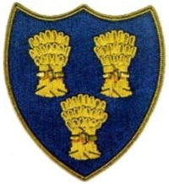
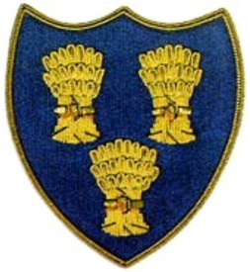
Cheshire Golf U14s
COURSE:- RINGWAY GOLF CLUB
DATE:- SUNDAY 5TH OCTOBER 2025
TIME:- ARRIVE 0915 LATEST – FIRST TEE 1008

Ringway Golf Club |  |  |  | Cheshire Golf U14s
Ellis Courtnell 0.9 | 2 |  | 3/2 | George Bull-Disley 1.4 | 2
Ben Davies 2.1 | 3 |  | 8/7 | Alfie Ogden-Wallasey 2.9 | 4
Toby Cooper 5.1 | 7 |  | 1Up | Jeremy Ju-Hazel Grove 4.7 | 6
Leo Warburton 6.4 | 8 |  |  | James Prest-Romiley 4.8 | 6 |  | 2Up
Lucas Moolla 7.2 (Capt) | 9 |  |  | Alfie Dunbar-Heswall 5.7 | 8 |  | 3/2
James Bell 8.9 | 11 |  | A/S | Henry Quinn-Disley 7.4 | 10 |  | A/S
Alex Le 9.9 | 13 |  |  | Cruz Norton-Northenden 9.0 | 12 |  | 2/1
Cameron White 11.9 | 15 |  |  | Adam Van Vuuren-Astbury 8.2 | 11 |  | 1Up
Josh Macklin 13.8 | 17 |  | 5/3 | Callum Miller-Wallasey 9.0 | 12
Zak McKenna 19.0 | 24 |  |  | Jamie Yarwood-Sandiway 9.6 | 13 |  | 2/1
 |  |  | 4.5 |  |  |  | 5.5

